**MUHAMMAD AZRI BIN ZAINUDDIN WER150018**

**TUTORIAL 1**

**Question 1**

ENTITY week2_q IS

PORT (a, b, c : IN BIT ;

d, e : OUT BIT);

END week2_q;

ARCHITECTURE LogicFunction OF week2_q IS

BEGIN

d <= ((a) and (b)) or (c);

e <= (b) and (c);

END LogicFunction;

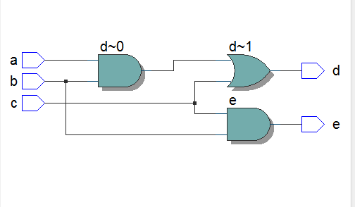

**Question 2**

|  |  |  |  |  |
| --- | --- | --- | --- | --- |
| **A** | **B** | **Cin** | **Cout** | **S** |
| 0 | 0 | 0 | 0 | 0 |
| 0 | 0 | 1 | 0 | 1 |
| 0 | 1 | 0 | 0 | 1 |
| 0 | 1 | 1 | 1 | 0 |
| 1 | 0 | 0 | 0 | 1 |
| 1 | 0 | 1 | 1 | 0 |
| 1 | 1 | 0 | 1 | 0 |
| 1 | 1 | 1 | 1 | 1 |

**Proving Formula**

Cout  = Sum of (3, 5, 6, 7)

= A’BC + AB’C + ABC’ + ABC

= C (A’B + AB’) + AB (C + C’)

= C (A XOR B) + AB

S = Sum of of (1, 2, 4, 7)

= A’B’C’ + A’BC’ + AB’C’ + ABC

= A’ (B’C + BC’) + A (B’C + BC)

= A’ (B XOR C) + A (B XOR C)

= A XOR B XOR C

ENTITY week2_q2 IS

PORT (a, b, cin : IN BIT;

s, cout : OUT BIT);

END week2_q2;

ARCHITECTURE LogicFunction OF week2_q2 IS

BEGIN

s <= (a) xor (b) xor (cin);

cout <= ((((a) xor (b)) and (cin)) or ((a) and (b)));

END LogicFunction;

